Practical no. 19
Name :- Danish Altaf Solkar Enrolment no. :-24111590805
Class :- CO3K – B Subject :- DMS
Aim:- Implement PL/SQL program using Iterative Statements

Program :-
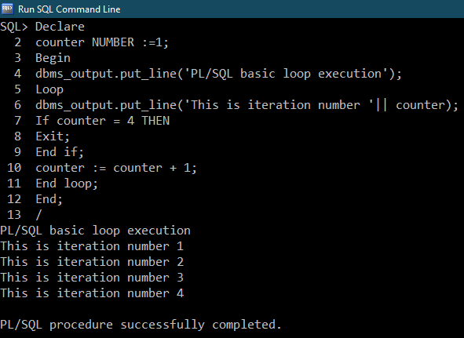

Program :-
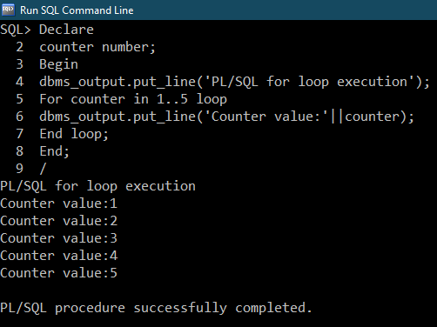
Program :-
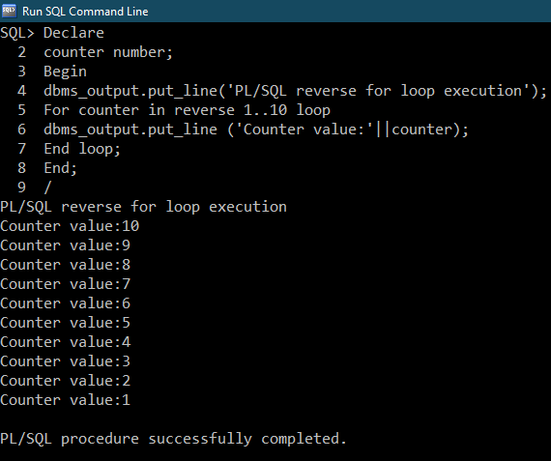

Program :-
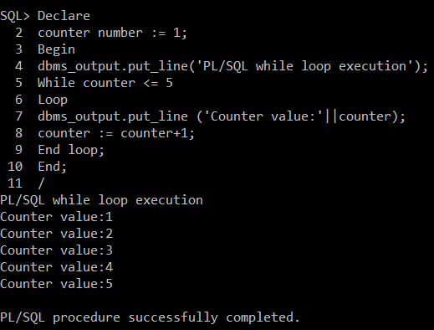

Practical related questions :-
1) Program :-
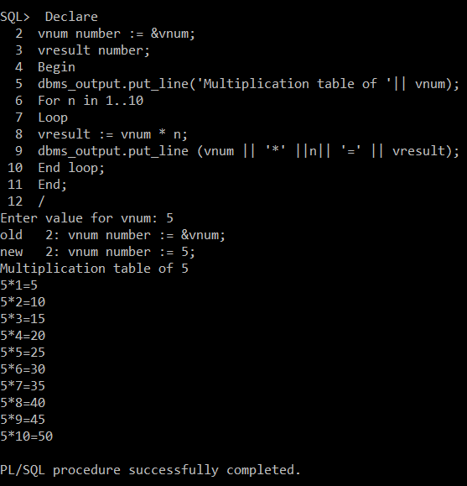

2) Program :-
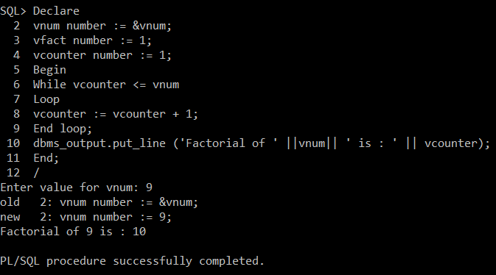
3) Program :-
